**Fop Lab Home Task 6**

**Name:** Hafiz Mufassir Amjad

**CMS ID:** 456049

**Section:** B

**TASK 1**

#include <iostream>

using namespace std;

int main()

{

int sum = 0;

for (int i = 1; i<=50; i++) {

int factors=0;

for (int j = 1; j<=i; j++) {

if (i%j==0) {

factors++;

}

}

if (factors == 2) {

sum += i;

}

else {

continue;

}

}

cout<<"Sum of all primary numbers from 1 to 50 is "<<sum;

}

**Output**

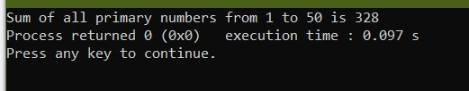

**Explanation**

This code runs a loop from 1 to 50 and calculate the factors of each number. If the factors of a number are 2, then the number is primary number. It also uses a continue statement to skip over non-primary numbers.The program then adds the primary number to a variable called sum. At the end of calculating the sum of all primary numbers, it prints out the sum.

**TASK 2**

#include <iostream>

using namespace std;

int main()

{

int rows;

cout<<"Enter number of rows: ";

cin>>rows;

for (int i = 1; i<=rows; i++) {

for (int j = 1; j<=i; j++) {

cout<<" "<<j;

}

cout<<endl;

}

}

**Output**

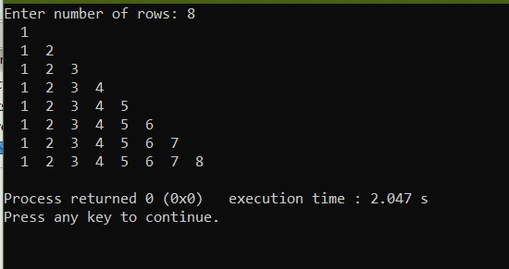

**Explanation**

This code takes number of rows from the user and prints out a pattern of increasing numbers using nested for loops. Outer loop calculates the number of row and inner loop calculates the position of the digit.

**TASK 3**

#include <iostream>

using namespace std;

int main()

{

int rows;

cout<<"Enter number of rows: ";

cin>>rows;

cout<<" 1\n";

for (int i = 1; i<=rows*2-1; i++) {

if (i%2==1){

continue;

}

for (int j = 1; j<=i; j++) {

cout<<" "<<i;

}

cout<<endl;

}

}

**Output**

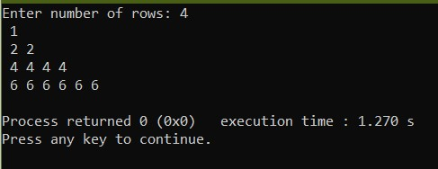

**Explanation**

This code takes number of rows from the user. It uses continue statement to skip over odd numbers except 1 and it prints out n digits of value n for number n. For example it prints 4 digits of value 4 for number 4.